EMBIT COMPANT LIMITED
Quality. Professionalism. Reliability

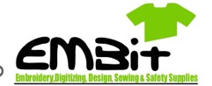
EMBIT
COMPANY LIMITED BUSINESS PROPOSAL

1. Executive Summary
EMBIT Company Limited is a proudly Ghanaian-owned company specializing in the manufacture, supply, branding, embroidery, and customization of corporate garments and industrial safety wear.
Since 2008, we have successfully partnered with leading organizations in mining, oil & gas, logistics, hospitality, construction, manufacturing, and public sectors by delivering premium-quality uniforms and personal protective equipment (PPE).
Our competitive advantage lies in exceptional workmanship, modern embroidery technology, competitive pricing, and dependable delivery schedules.

2. About EMBIT
Who We Are
EMBIT is a complete garment solutions company providing organizations with professionally designed and branded apparel that promotes safety, corporate identity, and durability. We specialize in the production and supply of corporate and industrial uniforms, workwear, safety wear, customized garments, embroidery, printing and sewing services. Our operations are driven by quality, professionalism, innovation, customer satisfaction and timely delivery.
We work closely with our clients to understand their specific requirements and provide products that meet their standards, specifications and budgets. With a strong commitment to excellence and continuous improvement, EMBIT Company Limited aims to become a trusted and dependable partner for organizations seeking quality garment production, branding, and supply solutions.

Mission Statement
To provide high-quality garments and branding services at competitive prices while delivering unmatched customer satisfaction through professionalism, innovation, and integrity.

Vision
To become Ghana's leading provider of corporate apparel and industrial safety wear across West Africa.

3. Our Products & Services
At EMBIT Company Limited, we provide quality products and reliable services tailored to meet the needs of individuals, businesses, institutions, construction companies, and organizations
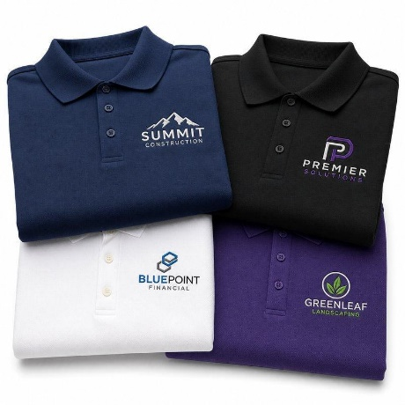
Figure 1: Polo Shirts - Customized with Embroidery or Print Figure 2: Executive - Premium long and short office wear

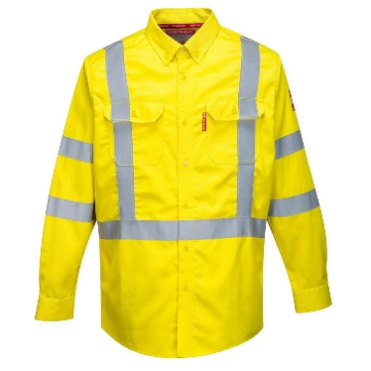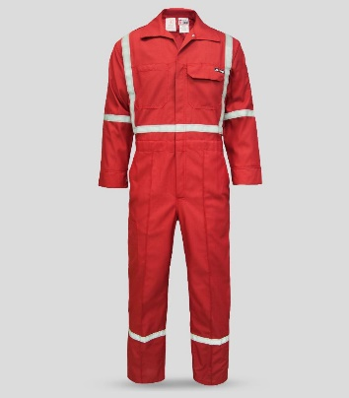
Figure 3: Reflective Coveralls - Mining, Engineering & Oilfields Use Figure 4: Hi - Visibility Wear Reflective Industrial Garments
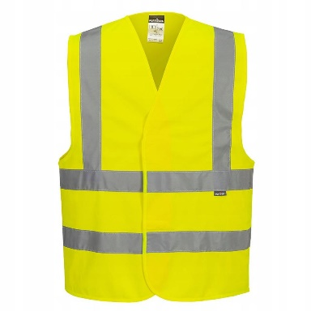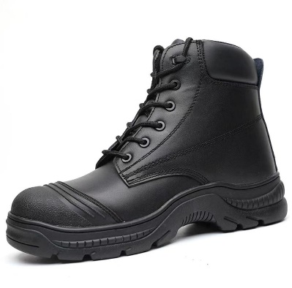
Figure 6: Safety Vests - ANSI - Style Visibility Protection Figure 5: Safety Boots - Protective Footwear for industrial Workplace
Additional Services
- Computerized embroidery & logo digitizing
- Screen printing
- Heat transfer branding
- Custom towels & promotional items
- Bulk corporate uniform production

4. Industries We Serve
We proudly provide products and services to:
- Mining Companies
- Oil & Gas Industry
- Construction Firms
- Logistics Companies
- Hotels & Hospitality
- Schools & Universities
- Government Institutions
- Manufacturing Companies

5. Why Choose EMBIT?
At EMBIT, we don’t just supply products-we build lasting relationships through quality, trust, reliability, and excellent customer service. We are equipment to handle both small and large orders, making us a reliable partner for companies, institutions, and organizations as well as
18+ Years Experience
Trusted expertise since 2008
Premium Quality Fabrics
Long-lasting materials and accessories
Modern Embroidery Technology
Accurate, high-quality branding
Nationwide Delivery
Reliable turnaround across Ghana
Our commitment is not simply supplying garments—we help organizations project a professional brand image while ensuring employee comfort and safety.

6. Our Valued Clients
At EMBIT company Limited Our clients are at the heart of everything we do. We are proud to serve a wide range of customers across different sectors, providing quality products and dependable services tailored to their specific needs. We value every client, regardless of the size of the order. Our commitment to quality timely delivery, competitive pricing, and excellent customer service has helped us build strong and lasting business relationships
Some organizations we have proudly served include:
- Tullow Oil Ghana
- OMA Logistics
- Bolloré / Antrak
- Ghana Manganese Company
- Kal Tire Mining
- Protea Hotel
- Diamond Cement
- Global Energy
- Conship Ghana
- HGS Ghana
These successful partnerships demonstrate our capacity to handle both small and large-scale corporate orders.

7. Quality Assurance
At EMBIT Company Limited, every product manufactured by EMBIT undergoes rigorous quality inspection before delivery. We are committed to delivering products and services that meet our customers expectations and required specifications
Our quality process includes:
- Fabric inspection
- Accurate cutting & stitching
- Professional embroidery verification
- Size confirmation
- Final finishing & packaging
This ensures every client receives products that meet the highest professional standards.

8. Delivery & Production Capacity
At EMBIT COMPANY LIMITED we understand the importance of timely delivery, particularly for corporate and industrial projects. We plan production schedules according to agreed delivery dates and coordinate logistics to ensure completed orders reach clients safely and on time.
Service | Estimated Delivery
Embroidery | 2–5 Working Days
Polo Shirts | 5–10 Working Days
Corporate Shirts | 7–14 Working Days
Industrial Uniforms | 10–21 Working Days
Bulk Orders | As Scheduled
Delivery timelines may vary depending on order quantity.
9. Our Commitment
EMBIT Company Limited is committed to building long-term partnerships through reliability, quality, and excellent customer service. We believe every garment we produce represents our client's brand, and we treat every project with the highest level of professionalism.
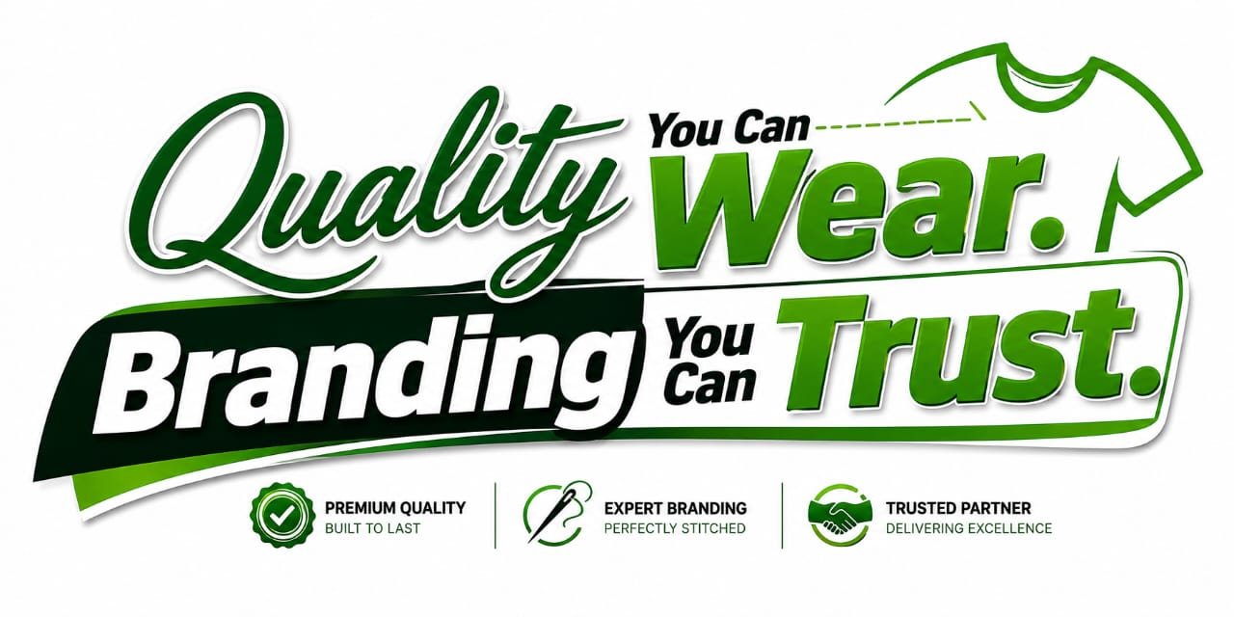
Thank You
Richard FrImpong
General Manager

EMBIT COMPANY LIMITED,
We sincerely appreciate the opportunity to submit this proposal and look forward to serving your organization.

